**Lab 4: ENVI Intro and Classification with Landsat**

35 points possible

*A PDF of this report must be uploaded to Gradescope by 10 am on Tuesday, February 22, 2022 (see submission instructions on Brightspace, and check Brightspace for due date updates).*

NAME: Kris Laferriere

1. (a) What is the pixel scale (resolution) of this image? (1 pt)

15 meters

(b) What is the approximate average width of the Colorado River in the image, in meters? (1 pt)

The approximate width is 8 pixels or 15*8 meters. 120 m

In three locations:

94.2773 meters

113.5693 m

154.2847 meters

Average width in the scene around Moab is

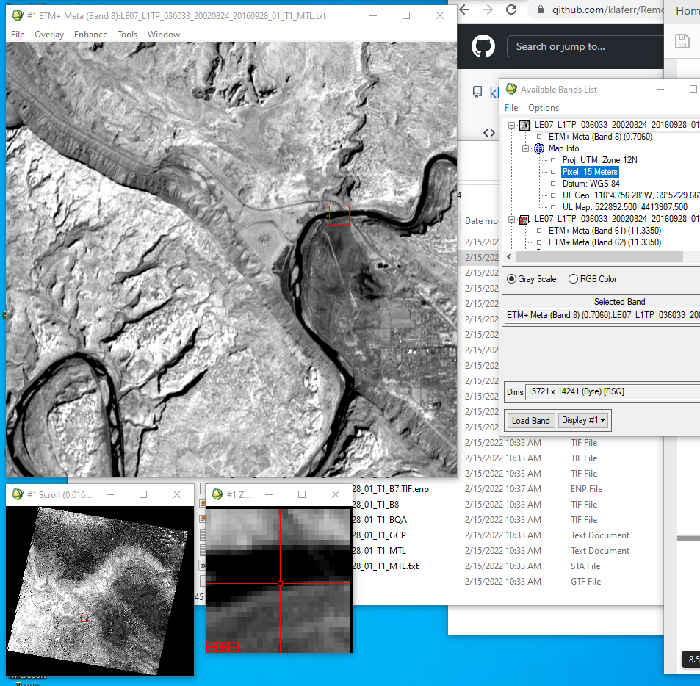

2. RGB Color Stretches

(a) Paste your true color Landsat 3/2/1 RGB composite image below. (1 pt)

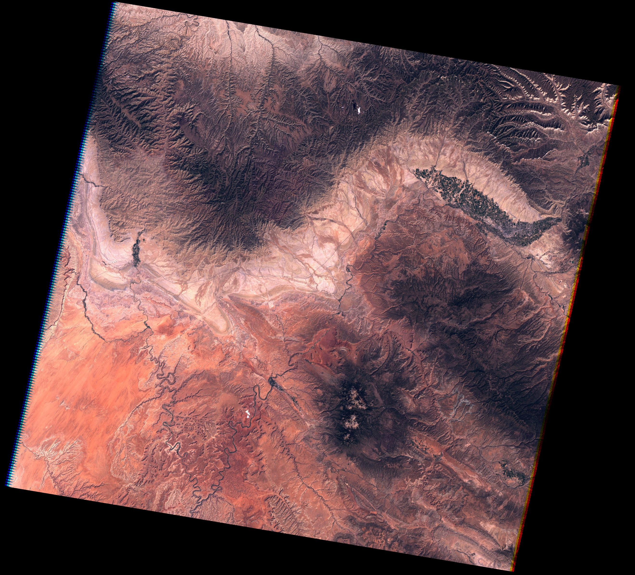



(b) How did you create a true color image? (1 pt)

Picked the max and min (visually) for each color band, picked the max and min out of those 6 and set that as the max for each filter.

(c) What color is most of the bedrock in this stretch? (1 pt)

The bedrock is a dark brownish color.

(d) Paste your false color Landsat 3/2/1 RGB composite image below. (1 pt)

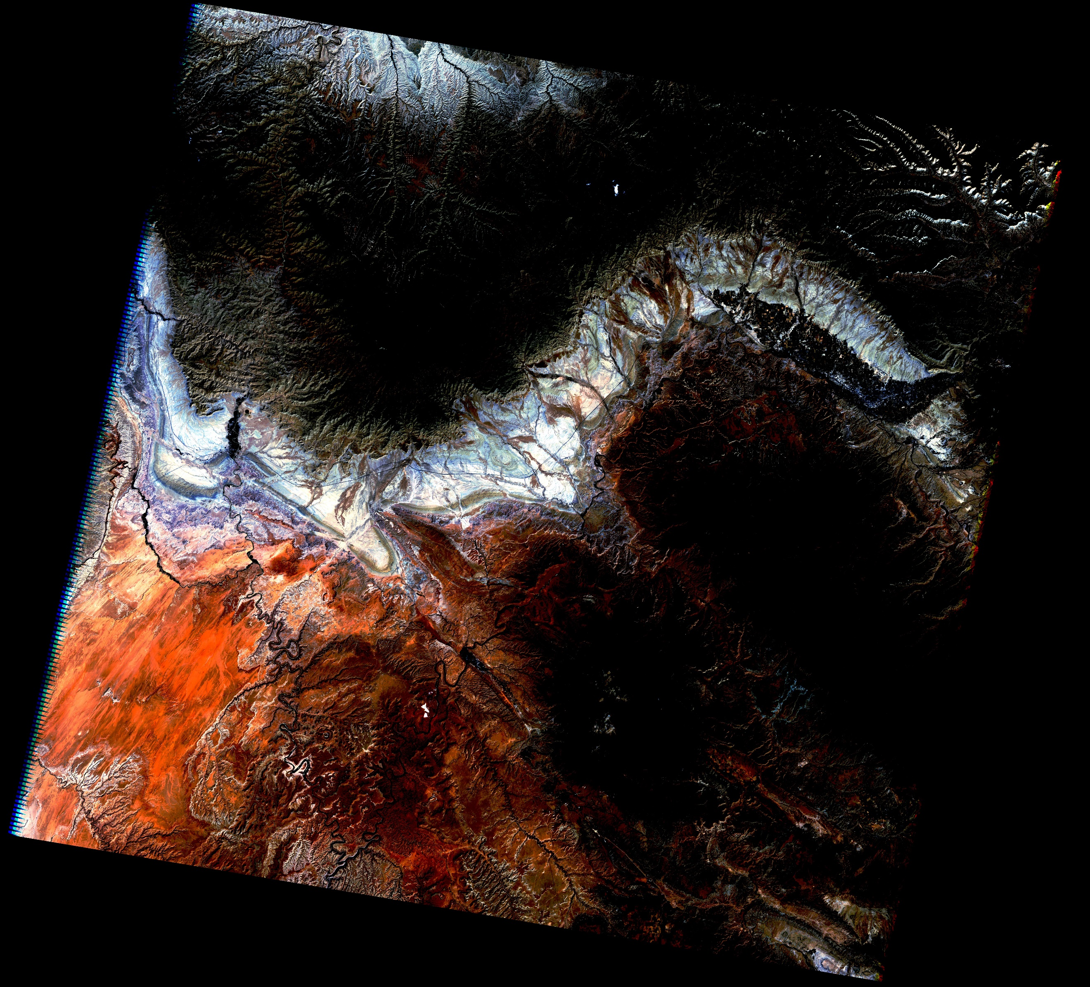

(e) Explain why you chose the stretch that you did - what were you trying to emphasize or show? (2 pts)

Because I couldn’t make a good one.

3. False color band combinations

(a) Paste your false color Landsat 4/3/2 RGB composite image below. (1 pt)

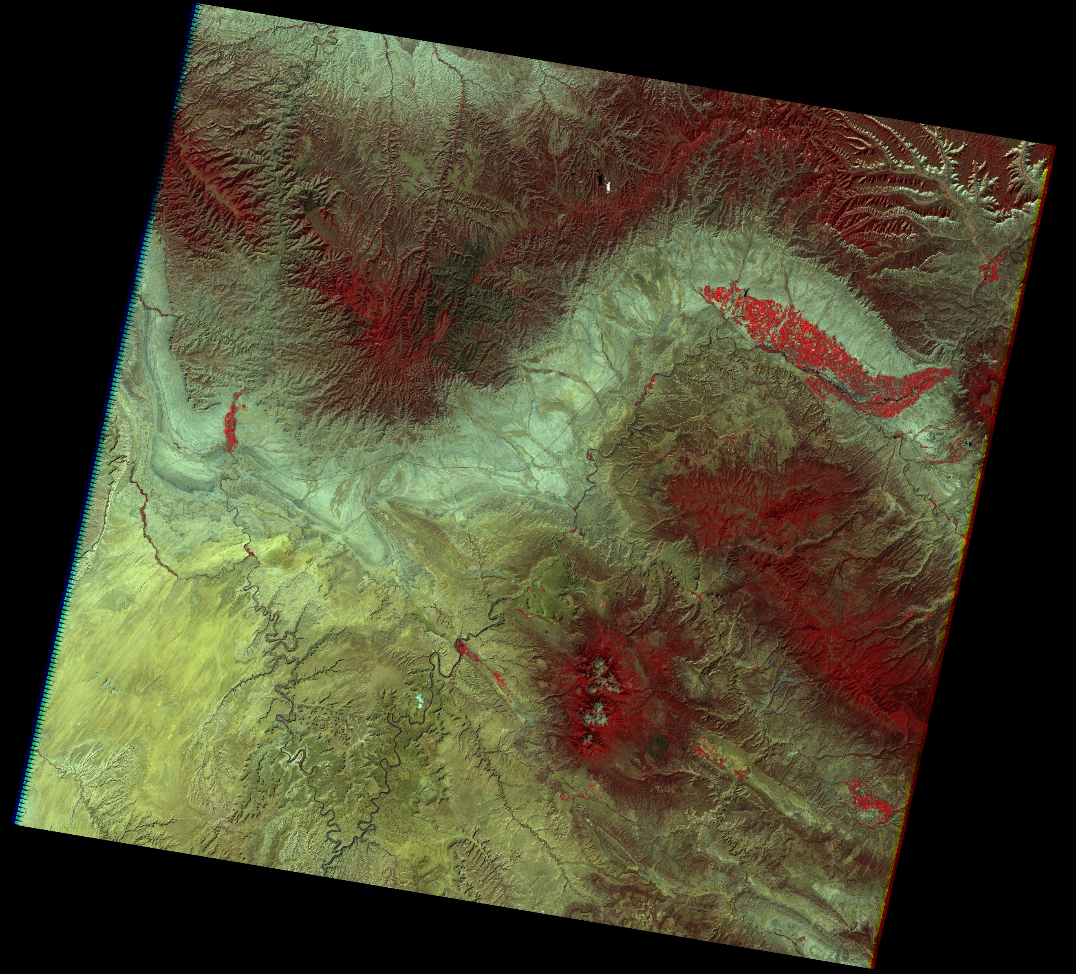

(b) Paste your false color Landsat 5/4/3 RGB composite image below. (1 pt)

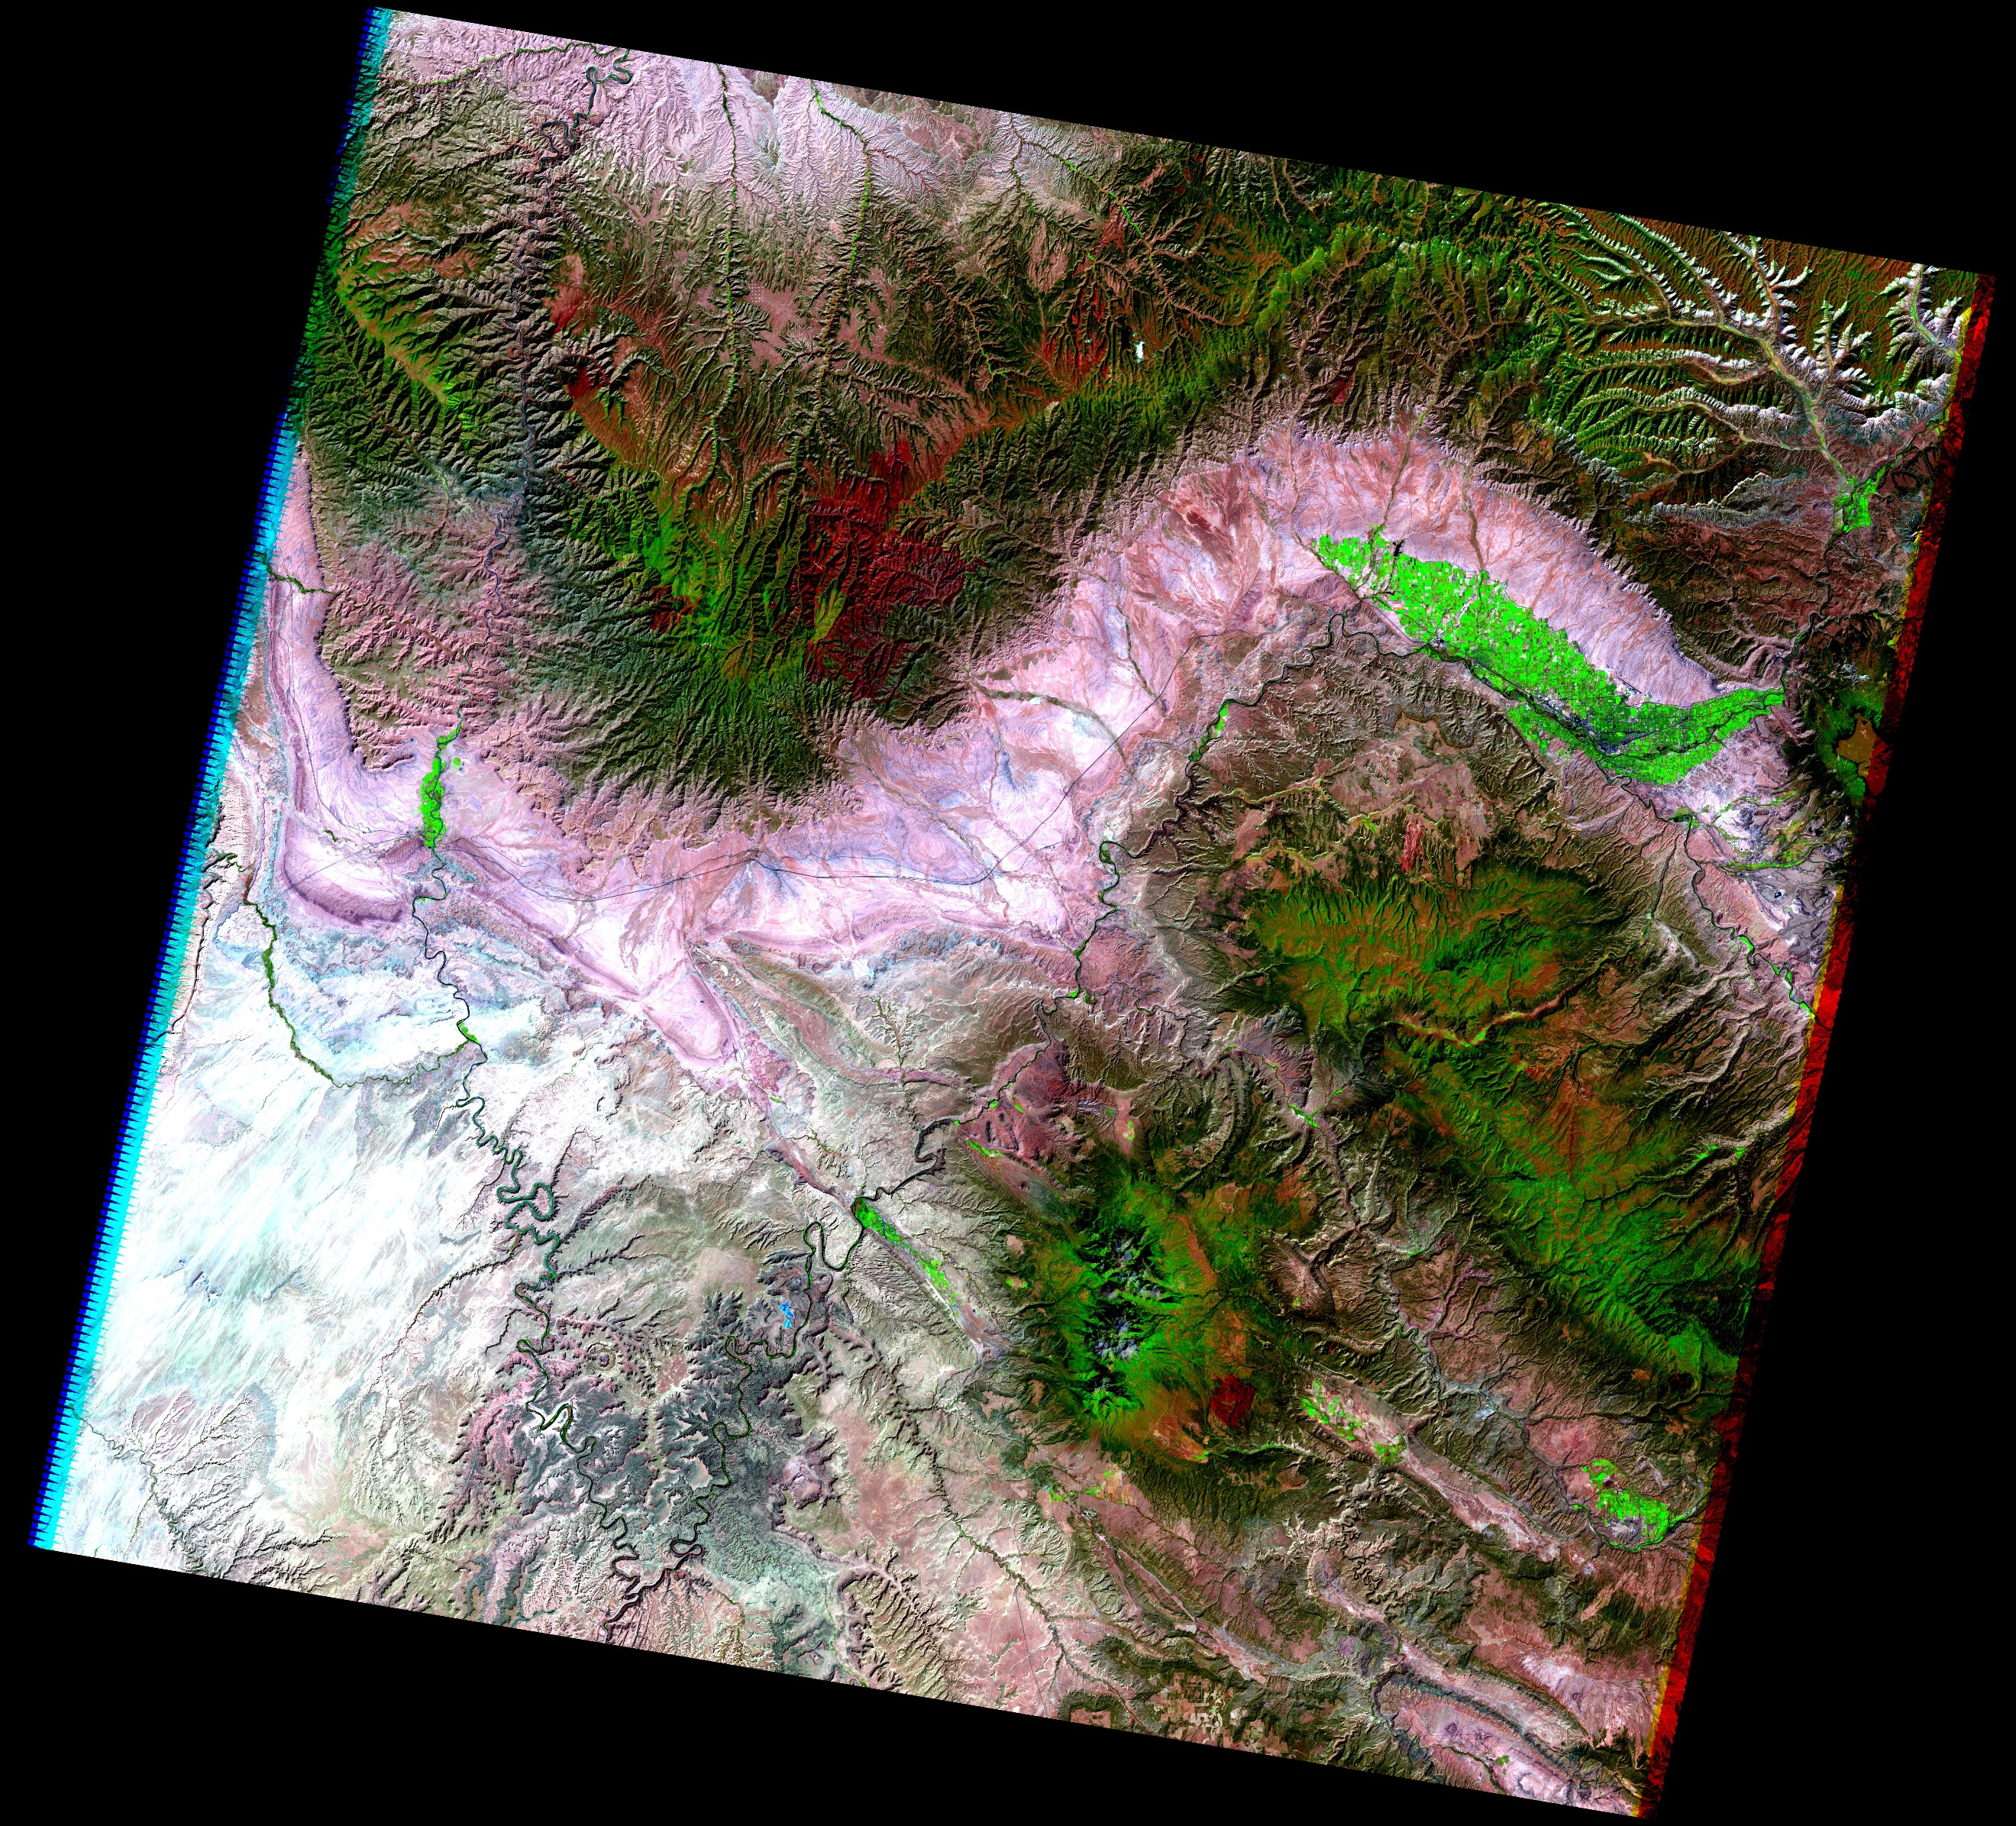

(c) What three colors does vegetation correspond to in the 5/4/3 and 4/3/2 images? (2 pts)

In 5/4/3, vegetation is bright green (crops), darker green (natural), and maroon (one section in the north western portion)

In 4/3/2, vegetation is red (crops), maroon (natural), and teal (north wester)

(d) Where are these color classes located in the image? (2 pts)

Northeastern, eastern, north western.

Draw

(e) Based on the plot that shows some common types of vegetation along with the Landsat 7 bands, what type of vegetation do you think these areas are dominated by? (2 pts)

In 4/3/2, the red crops are probably grass, fir tree or a walnut canopy. The maroon are dry yellowed grass, and the teal is I have no idea.

In 5/4/3, the bright green is grass. The darker green is likely dry yellowed grass, and the maroon is likely I also don’t know.

4. Masking

1. What is the approximate range of values in band 5 over the river? (1 pt)

5-25 around Moab.

1. Paste your stretched image emphasizing the river below (1 pt)

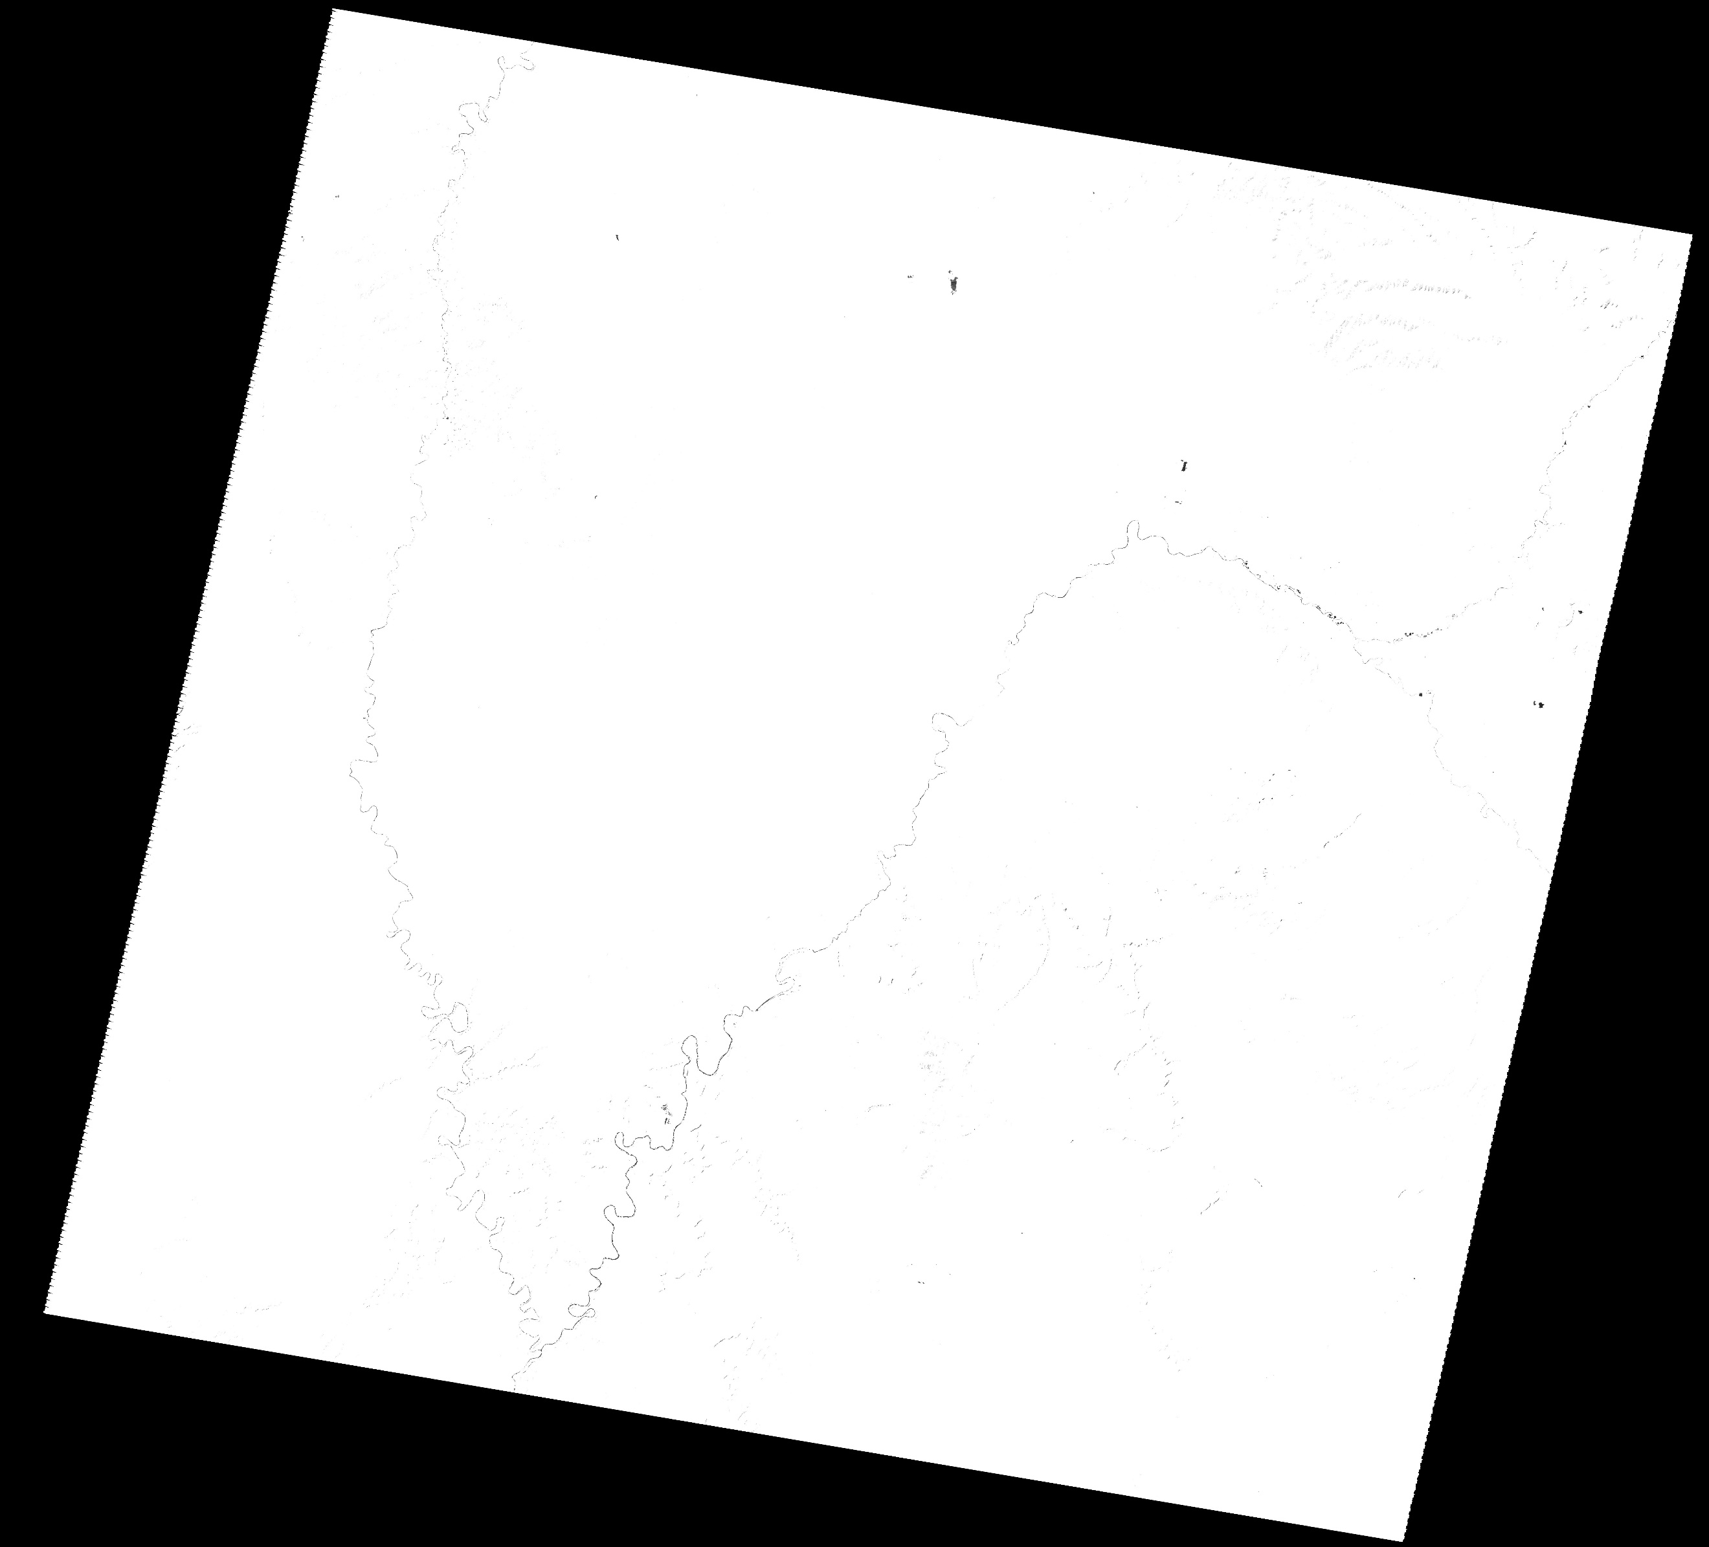

1. Is the river the only part of the scene that is dark? If not, what do these areas correspond to? (1 pts)
2. Paste your water mask image below (1 pt)

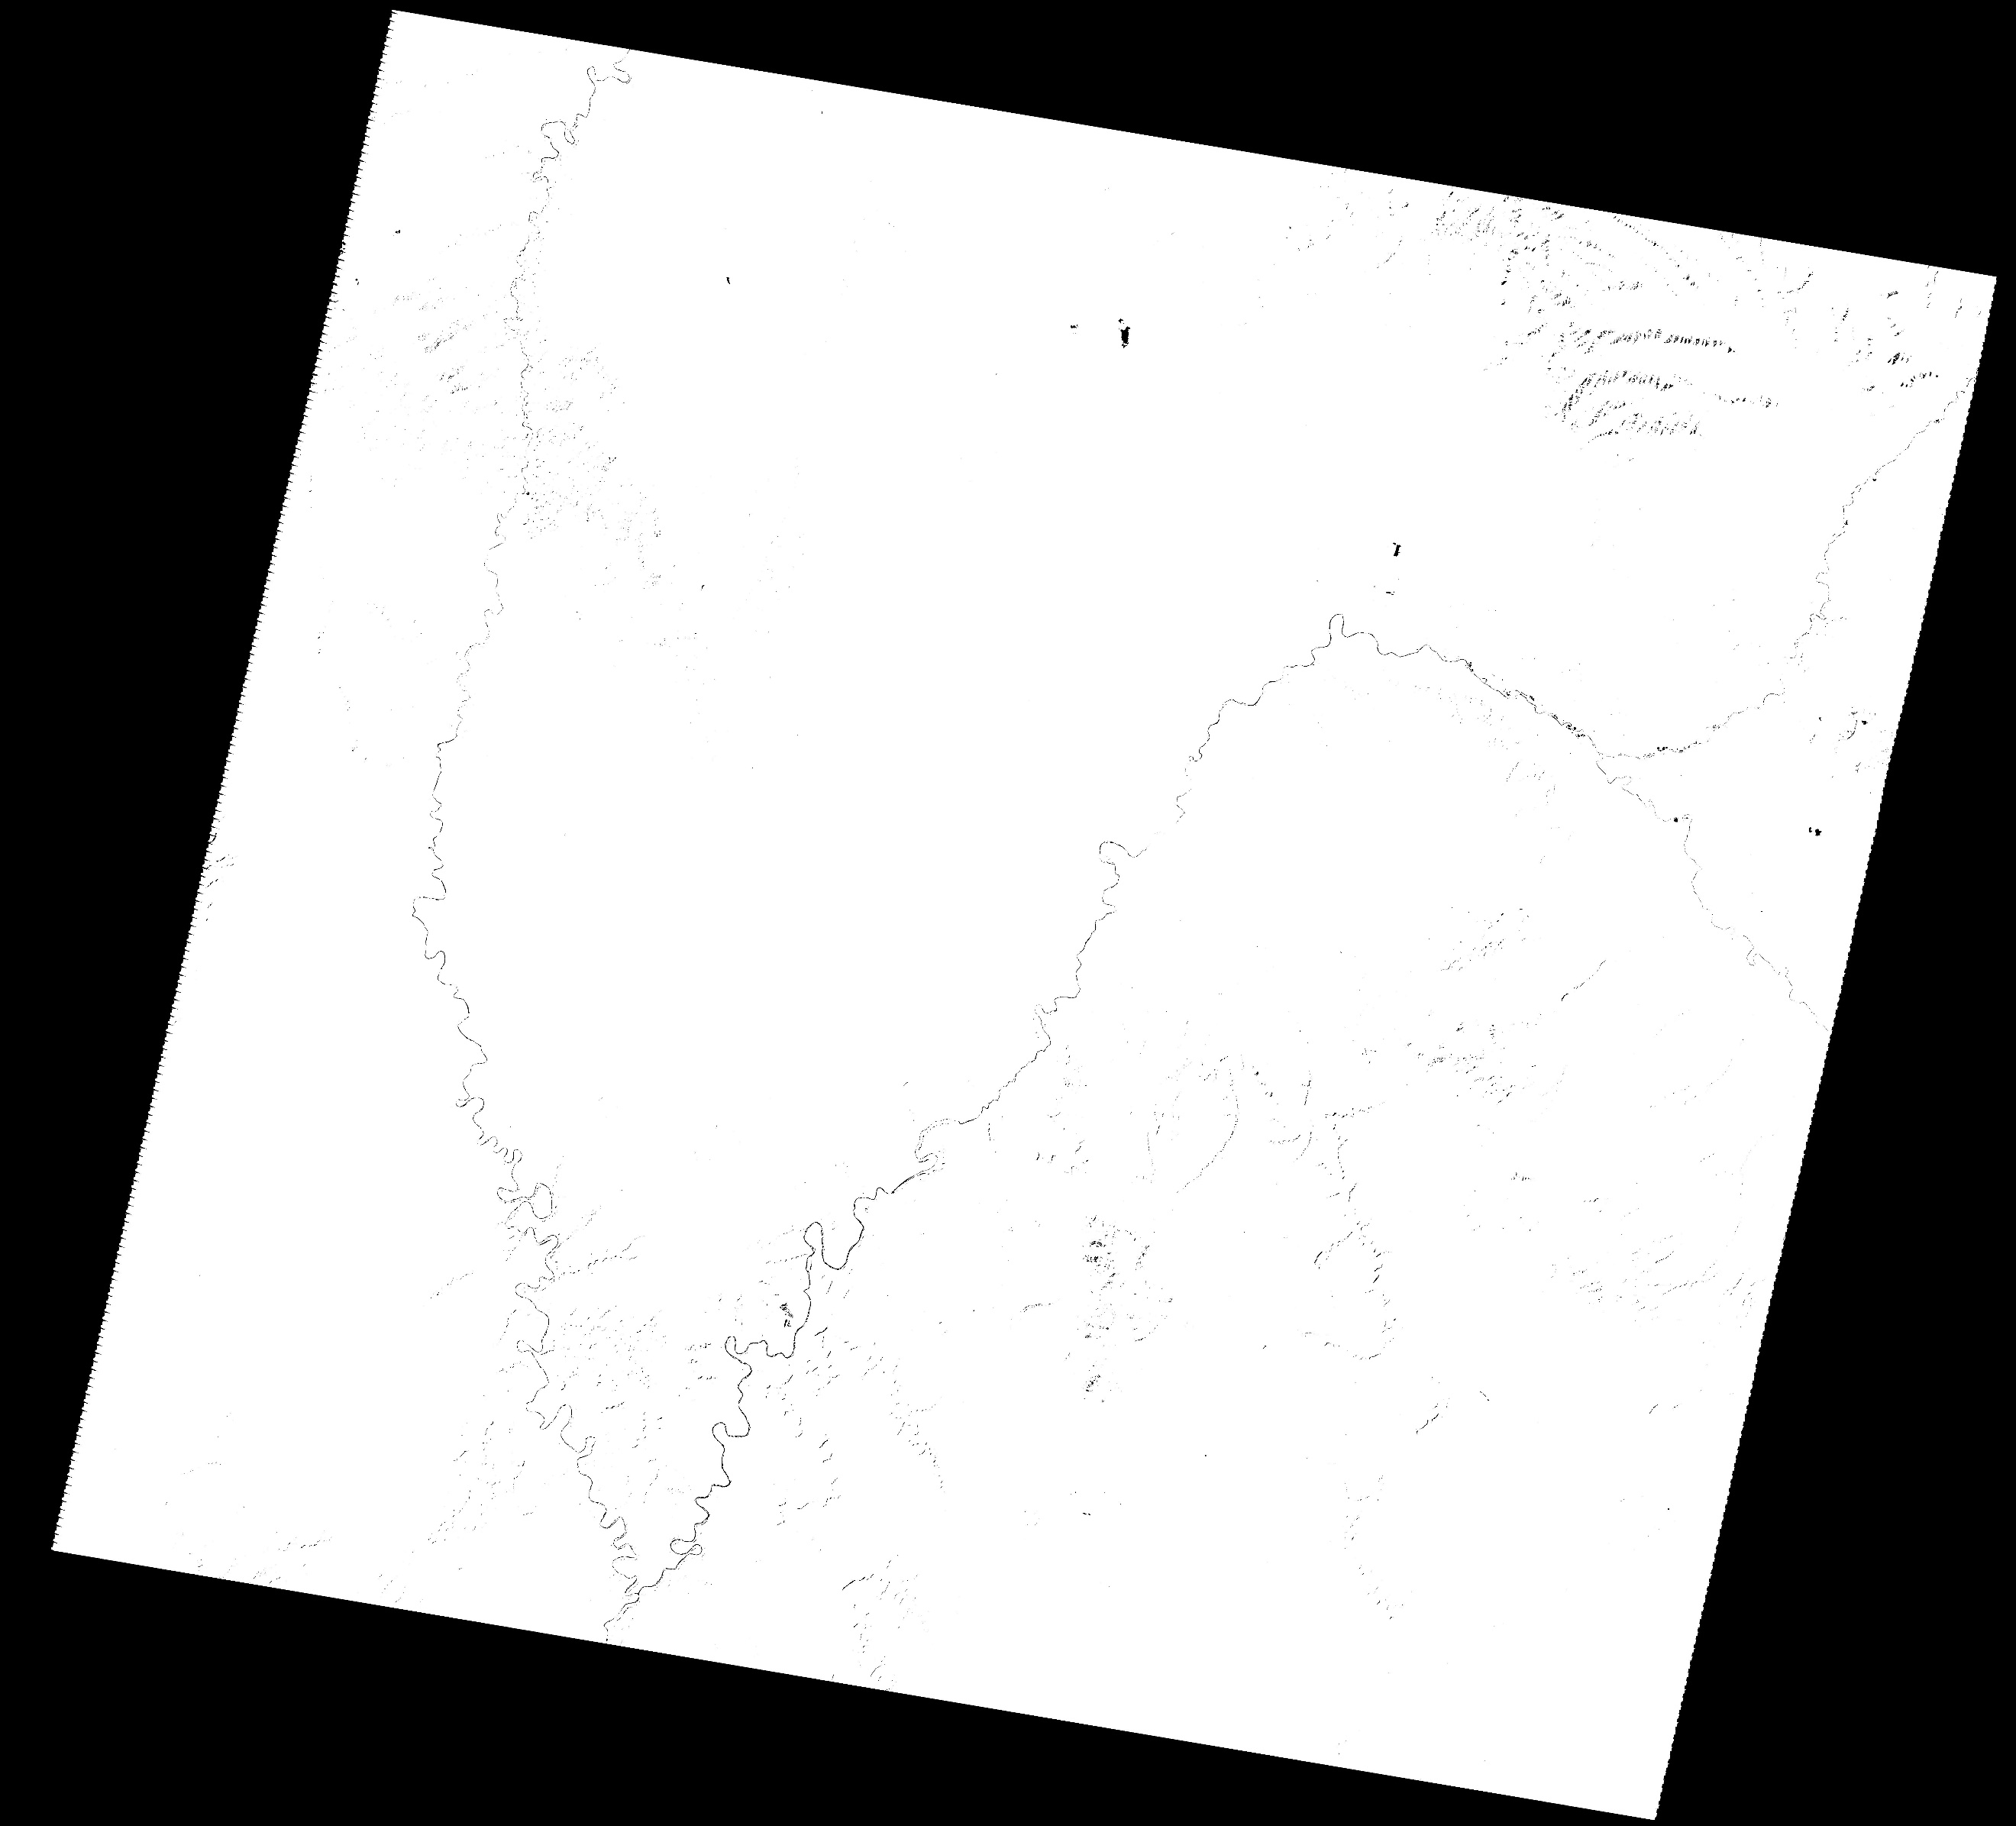

5. Band math

1. Based on the spectral plots, what band ratio should you use to identify green vegetation and why? (2 pts)

Band ratio for green veg. 7/4 will be the opposite of soil.

1. Why did I add a 1.0 to the equation “b1*1.0 / b2” that you entered in the band math dialogue (hint: what kind of numbers are the arrays composed of)? What would have happened if I didn’t? (1 pts)
2. Paste your vegetation ratio image below (1 pt)

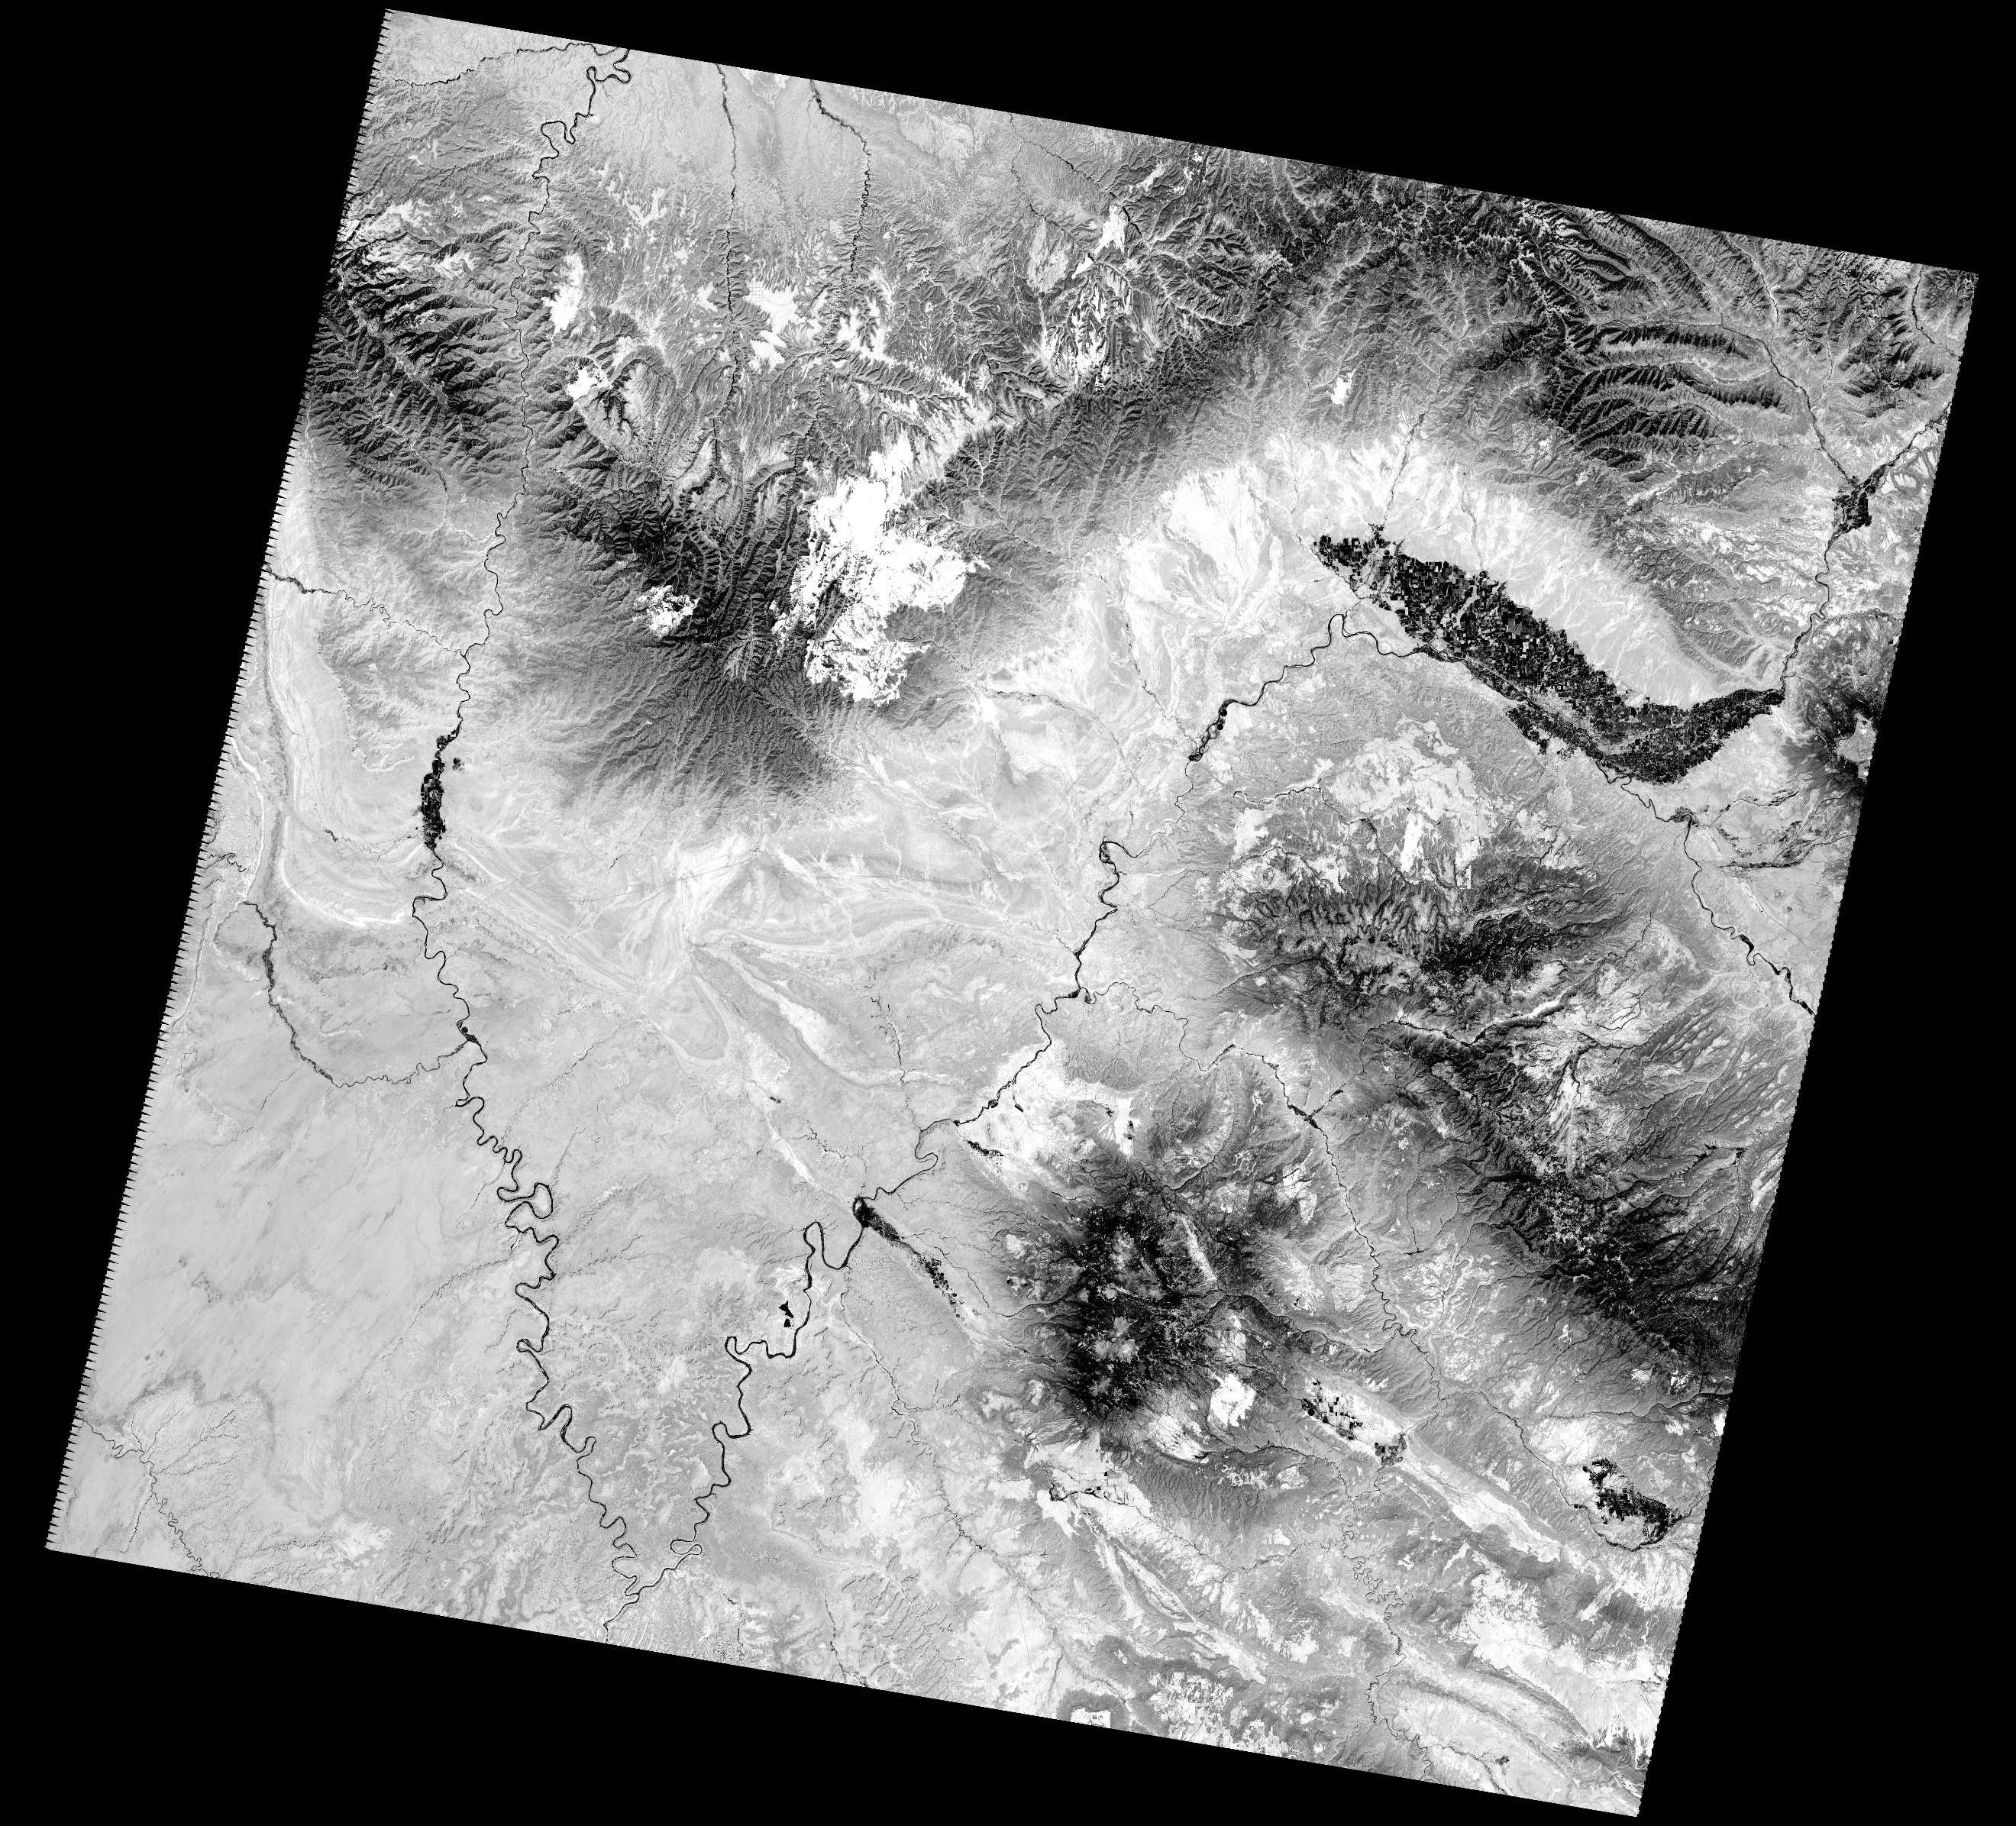

1. Did you successfully map vegetation? What does the strength of the parameter correspond to? (2 pts)
2. What are the ranges of values of this parameter that correspond to relatively dense vegetation (this is a little subjective)? (2 pts)
3. Paste your vegetation mask image below (1 pt)

6. Rocks!

1. Create your favorite rock stretch band combination image and paste it below. (1 pt)
2. Why did you choose this combination? What kind of variability do you see in the scene? (3 pts)
3. Paste your masked rock image below (1 pt)
4. Did the mask help you stretch the image more accurately? (1 pts)